**Technical Documentation – PENC MiddleWare – Cronacle Service Control**

1. Workflow – Stops, Starts, Restarts the Cronacle Weblogic Managed Server (m1) for Development and Test Environments, typically during Database Refreshes.

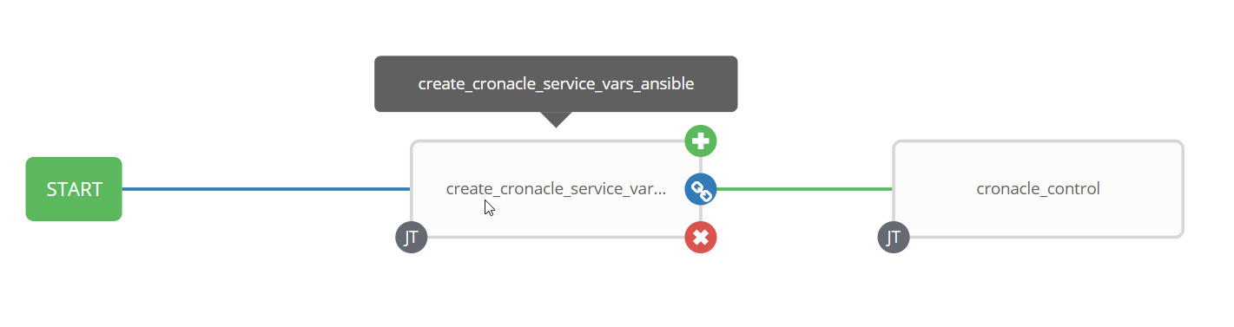

1. Survey – User Supplied Variables

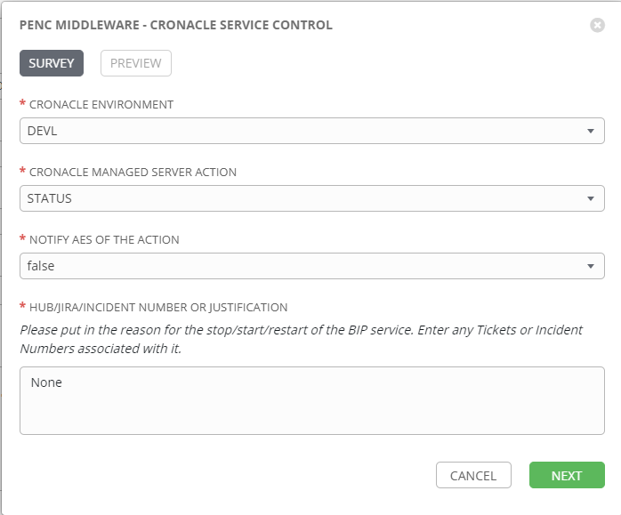

| **Survey Extra Variables** | **Prompt** | **Type** | **Description and Usage** |
| --- | --- | --- | --- |
| ENV | Cronacle Environment | Multiple Choice Single Pick | This is a drop down list of the current Cronacle Environments  DEVL  RDEV  DEV3  TST1  TST2  TST3 |
| cronacle_command | Cronacle Managed Server Action | Multiple Choice Single Pick | The available commands for the Cronacle Environment  Drop Down List:  RESTART  START  STATUS  STOP |
| notify_aes | Notif AES Of The Action | Multiple Choice Single Pick | If set to true send an email to the email addresses defined in {{aes_mail_list}}. |
| aes_note | HUB/JIRA/INCIDENT Number or Justification | Text Area (20000 characters) | Any information entered here will be included in the emails generated. |

1. Jobs Used by the workflow - http://owl.penc.local:18080/svn/deploy_automation/trunk/Ansible_PlayBooks/Utilities

| **Job Template** | **Ansible Playbook** | **Credentials / host** | **Project** | **Description and Usage** |
| --- | --- | --- | --- | --- |
| create_cronacle_service_vars_ansible | create_cronacle_service_vars_ansible.yml | None – runs on localhost as awx linux user | Utilities | Creates Variables/Artifacts for use within the workflows, based on the User supplied survey results.  Artifacts Defined with examples  cronacle_admin_port: 9001  cronacle_domain: wls_domain_jct3  cronacle_host: thalassa1bcp  cronacle_m1_port: 9003  date_time: '20210822_0928'  domain_location: /pencmw/oracle/domains  oracle_base: /pencmw/oracle  oracle_home: /pencmw/oracle/fmw/oracle_home2  tower_host: pdeploy1bcp.penc.local  weblogic_home: /pencmw/oracle/fmw/oracle_home2/wlserver |
| cronacle_control | cronacle_control.yml | oracle for {{cronacle_host}}  PMP_ANSIBLE_AUTH_TOKEN for the Ansible Password Manager Pro API | Utilities | On {{cronacle_host}}:  Obtains the WEBLOGIC_ADMIN Resource and Accound IDs from password managerpro using the {{ans_auth_token}} by passing in ‘WEBLOGIC_ADMIN and {{ENV}}_JCS_WEBLOGIC_ADMIN to the getResourceAccountDetails API.  Obtains the password from Password Manager Pro by passing the RESOURCEID and ACCOUNTID to the getResourceAccountDetails API.  With {{cronacle_command}} == ‘STOP’ or ‘RESTART’  Retrieves the process id for the Cronacle Weblogic Admin Server into {{admin_weblogic_pid}} variable.  Retrieves the process id for the Cronacle Weblogic Manged Server (m1) to be stopped into {{m1_weblogic_pid}} variable.  Executes:  {{oracle_home}}/oracle_common/common/bin/commEnv.sh  {{domain_location}}/{{cronacle_domain}}/bin/setDomainEnv.sh  {{domain_location}}/{{cronacle_domain}}/bin/stopManagedWebLogic.sh m1 t3://{{cronacle_host}}:{{cronacle_admin_port}} weblogic_admin {{WeblogicAdminPassword}}  Waits for the /proc/{{m1_weblogic_pid.stdout}}/status to longer exist (i.e. weblogic managed server (m1) process no longer exists)  With {{cronacle_command}} == ‘START’ or ‘RESTART’  Executes:  {{oracle_home}}/oracle_common/common/bin/commEnv.sh  {{domain_location}}/{{cronacle_domain}}/bin/setDomainEnv.sh  cd {{domain_location}}/{{cronacle_domain}}/bin  nohup {{domain_location}}/{{cronacle_domain}}/bin/startManagedWebLogic.sh m1 t3://{{cronacle_host}}:{{cronacle_admin_port}} >/dev/null 2>1&  Waits for the {{cronacle_m1_port}} to be available  With {{cronacle_command}} == ‘STATUS’ or ‘STOP’ or ‘START’ or ‘RESTART’  Checks the url http://{{cronacle_host}}.penc.local:{{cronacle_m1_port}}/scheduler  Sends an email to the Ansible Tower user who initiated the workflow with the results  If {{notify_aes}} is set to true send an email to the addresses defined in {{aes_mail_list}} with the results |

1. Workflow Extra Vars – Defined at the Workflow Level

|  |  |  |
| --- | --- | --- |
| **Extra Variable** | **Example Values** | **Description and Usage** |
| pmp_url | pmp_url: 'https://acisbcp.penc.local:7272' | Password Manager Pro URL for the password datastore for the weblogic_admin account |
| aes_mail_list | aes_mail_list:  Mike.Charchuk@dxcas.com | If this variable is defined to anything other than ‘’ and {{notify_aes}} == true an email with the actions taken to addresses defined in {{aes_mail_list}}.  Note: the following are valid aes_mail_list entries:  aes_mail_list: ‘’  aes_mail_list:  [Mike.Charchuk@pensionsbc.ca](mailto:Mike.Charchuk@pensionsbc.ca)  [Mike.Charchuk@dxcas.com](mailto:Mike.Charchuk@dxcas.com)  aes_mail_list:  [Mike.Charchuk@pensionsbc.ca](mailto:Mike.Charchuk@pensionsbc.ca) |